Scripture Lessons Ann Robbins
1 Corinthians 13:4-8 & Isaiah 42:1-4
The Word of God for the people of God.

Thanks be to God.
*Singing Our Faith # 394 “Something Beautiful”
The Good News “The Flow of Strength”

Bringing Forward God’s Tithes and Our Gifts
*Doxology # 95 Praise God from whom all blessings flow; praise him, all Creatures here below; praise him above, ye heavenly host; praise Father, Son, and Holy Ghost. Amen.
*Prayer of Thanksgiving
Sharing of Joys and Concerns
The Lord’s Prayer

Our Father, who art in heaven, hallowed be thy name. Thy kingdom come, Thy will be done on earth as it is in heaven. Give us this day our daily bread and forgive us our trespasses, as we forgive those who trespass against us. And lead us not into temptation, but deliver us from evil. For thine is the kingdom, and the power, and the glory, forever. Amen.
*Singing Our Faith # 98 “To God Be the Glory”
*Blessing and Dismissal
*Postlude

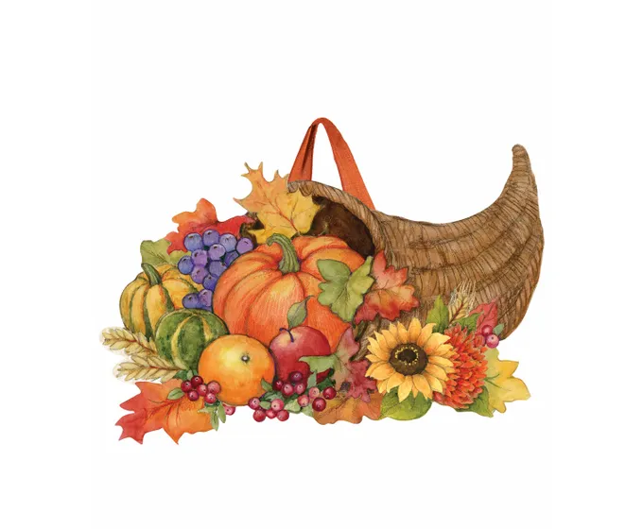

Happy Thanksgiving

C hestnut Hill
United Methodist Church

Making disciples of Jesus Christ
for the transformation of the world.
You are welcome at Chestnut Hill UMC.

4660 Fort Avenue ~ Lynchburg, Virginia 24502
Church: 434-239-8423
Minister’s Cell: 434-944-7723, Minister’s Email: awhite@ves.org
Associate Minister’s Cell: 1-502-489-0200
Associate Minister’s Email: healingsolutions12@gmail.com
Email: chestnuthillumc@comcast.net
On the Web at chestnuthillumc.net
Find us on Facebook: Chestnut Hill United Methodist Church

Chestnut Hill United Methodist Church
10:30 a.m. ~ November 19, 2023
Twenty-Fifth Sunday after Pentecost
Our ministry vision for the Virginia Annual Conference is “to be disciples of Jesus Christ who are lifelong learners, who influence others to serve.”

Welcome! Join us in worshiping God!

Prelude
Welcome and Ministry Announcements
Welcome in the name of Christ our Lord. Please register your attendance, printing your name, address, phone, and email, on the attendance pad provided on your pew. Thank you for silencing cell phones as we gather to worship God.
Invocation
*Greeting
Blessed are you who have realized that life is hard.
And it’s hard for everyone.
Your awareness came at a cost.
You lost something you can’t get back.
You were diagnosed with chronic pain or degenerative disease. Your family fell apart and things have never been the same.
Blessed are you who gave up the myth
that the good life is one of happiness, success, perfection.
The life that looks beautiful on Social Media, but isn’t real.
You who realize it is okay to not be okay.
To not have a shiny life because no one does.
Blessed are you who see things clearly,
where struggle is everyone’s normal.
You walk among the fellowship of the afflicted,
a club no one wants to join.
And while this life isn’t shiny, it does come with superpowers.

Superpowers of ever-widening empathy
and existential courage that gets you back up after another fall and a deepened awe at the beauty and love that can be found amid life’s rubble.
Like flowers that grow from the cracks in the sidewalk.
These virtues blossom in you. And thank God for you.
Blessed are all of us who struggle,
for we are in good company,
and we’ll never walk alone.
*Singing Our Faith # 62 “All Creatures of Our God and King”

*Opening Prayer
Blessed are we with eyes to see the person right in front of us, not solely their faults or some future version of themselves or the way they always do that thing that drives you nuts. But as poetry incarnate, as treasures to be beheld. Blessed are you who notice the light in their eyes or when that light dims. You who scoot up close to their suffering, though you might not have the right words to say. You who bear witness to their life in its entirety—the joys, the sorrows, the unfinishedness of it all. You who cherish every story (even if you’ve heard it before), listening without judgment and without haste. May your careful attention be met with others who see you as the same bright light and wonder that you are. As you practice seeing and being seen, may you remember that you too are a blessing to all who have the privilege to know you.

Special Music “Come, Ye Thankful People, Come”

Greeting Friends and Neighbors
Prayer for Illumination Ann Robbins
Living God, help us to hear your word that we may truly understand; that, understanding, we may believe; and believing, we may follow your way in faithfulness, seeking your honor and glory in all that we do. Amen

Scatter to Serve God & Neighbor

Welcome to all! We gather to praise God for the innumerable blessings given to us and to grow deeper in the Spirit. Joyfully, let us lift our hearts to God.
**Calendar **
Thursday, 11/23 | Happy Thanksgiving ~ Office Closed
Friday, 11/24 | Office Closed
Saturday, 11/25 | 10:00 a.m. | Christmas Decorating of Church For those who can help let Judy Robertson know.
**Looking Ahead on the Calendar **
Thursday, 11/30 | 10:00 a.m. | Merry Marthas Circle  We will have a devotional and World Thank Program/Offering. A short business meeting, then go out to lunch at Charley’s. We will not meet in December.

Angel Tree
We will be sponsoring an Angel Tree this year for the children of clients with Humankind’s Ways to Work program. We have 20 angels on the tree today. You may take one (or more) and shop for him or her, or you may make a monetary donation and the Humankind staff will do the shopping. There is a sign-up sheet by the Angel Tree. Please sign whether taking an angel or writing a check. All checks should be made out to “Chestnut Hill UMC”, with “Angel Tree “ on the memo line.
Gifts should be wrapped and the child’s name on each gift. Gifts and checks should be turned in by Sunday, December 10.
**NOTE: We will also collect mittens, gloves, scarfs, caps, and socks. These can be brought to church any time in December.

Advent Study

Erin Long is providing an Advent Study. It is continuing on Wednesdays, December 6 & 13 at 6:00 p.m., here at Chestnut Hill. If you would like to attend let Erin or the church office know.

Cards for Homebound Members

Please take a moment to sign the cards for our homebound members/friends that Erin has placed in the Commons.

District Advent Brunch
The District Advent Brunch for all women of the church (whether you belong to a circle or not) will be Saturday, Dec. 2, at 9:00 a.m. at Rustburg UMC. Cost is $5.00. Breakfast will be prepared by the women of the church. There will be a musical program by Kelly Henshaw. An offering will be taken for Fairview UMC Food Pantry. They will also collect items for Park View Community Mission. Let Judy Robertson know ASAP if you want to go and Judy will give you a list of items for PVCM. Frances Unruh and Judy Robertson are planning to go, and Judy will be glad to take 2 others. Judy’s cell phone #434-851-2901.

For the Grocery Cart:
November ~ Canned vegetables, stuffing mix, instant potatoes, rice, cranberry sauce, and any other side dish to make a great holiday meal. Place donations in the grocery cart, located in the Commons.

DIRECTORY OF CHESTNUT HILL UNITED METHODIST CHURCH
Sue Haupert-Johnson |  | Richmond Area Resident Bishop
 | Denise Bates |  | Mountain View District Superintendent
 | Adam White |  | Minister
 | Erin Long |  | Associate Minister
 | Monica Campbell |  | Administrative Assistant
 | Heather Wilson |  | Director of Music Ministry
 | Judy Martin |  | Bookkeeper
 | Judy Robertson  Elizabeth Nichols |  | Lay Leader  Missionary in Henry County

Scatter to Serve God & Neighbor

Welcome to all! We gather to praise God for the innumerable blessings given to us and to grow deeper in the Spirit. Joyfully, let us lift our hearts to God.
**Calendar **
Thursday, 11/23 | Happy Thanksgiving ~ Office Closed
Friday, 11/24 | Office Closed
Saturday, 11/25 | 10:00 a.m. | Christmas Decorating of Church For those who can help let Judy Robertson know.
**Looking Ahead on the Calendar **
Thursday, 11/30 | 10:00 a.m. | Merry Marthas Circle  We will have a devotional and World Thank Program/Offering. A short business meeting, then go out to lunch at Charley’s. We will not meet in December.

Angel Tree
We will be sponsoring an Angel Tree this year for the children of clients with Humankind’s Ways to Work program. We have 20 angels on the tree today. You may take one (or more) and shop for him or her, or you may make a monetary donation and the Humankind staff will do the shopping. There is a sign-up sheet by the Angel Tree. Please sign whether taking an angel or writing a check. All checks should be made out to “Chestnut Hill UMC”, with “Angel Tree “ on the memo line.
Gifts should be wrapped and the child’s name on each gift. Gifts and checks should be turned in by Sunday, December 10.
**NOTE: We will also collect mittens, gloves, scarfs, caps, and socks. These can be brought to church any time in December.

Advent Study

Erin Long is providing an Advent Study. It is continuing on Wednesdays, December 6 & 13 at 6:00 p.m., here at Chestnut Hill. If you would like to attend let Erin or the church office know.

Cards for Homebound Members

Please take a moment to sign the cards for our homebound members/friends that Erin has placed in the Commons.

District Advent Brunch
The District Advent Brunch for all women of the church (whether you belong to a circle or not) will be Saturday, Dec. 2, at 9:00 a.m. at Rustburg UMC. Cost is $5.00. Breakfast will be prepared by the women of the church. There will be a musical program by Kelly Henshaw. An offering will be taken for Fairview UMC Food Pantry. They will also collect items for Park View Community Mission. Let Judy Robertson know ASAP if you want to go and Judy will give you a list of items for PVCM. Frances Unruh and Judy Robertson are planning to go, and Judy will be glad to take 2 others. Judy’s cell phone #434-851-2901.

For the Grocery Cart:
November ~ Canned vegetables, stuffing mix, instant potatoes, rice, cranberry sauce, and any other side dish to make a great holiday meal. Place donations in the grocery cart, located in the Commons.

DIRECTORY OF CHESTNUT HILL UNITED METHODIST CHURCH
Sue Haupert-Johnson |  | Richmond Area Resident Bishop
 | Denise Bates |  | Mountain View District Superintendent
 | Adam White |  | Minister
 | Erin Long |  | Associate Minister
 | Monica Campbell |  | Administrative Assistant
 | Heather Wilson |  | Director of Music Ministry
 | Judy Martin |  | Bookkeeper
 | Judy Robertson  Elizabeth Nichols |  | Lay Leader  Missionary in Henry County

